SkillGame
Build, Theory of Operation & Service Manual
A modern recreation of Bally's 1955 Skill-Roll nickel-flip game, run from a Windows mini-PC over four FT232H USB boards. This manual covers the hardware, first-time setup, wiring, how the software is put together and how it flows, what every class and function does, what every LED pattern looks like, what every diagnostics control does, the audit system, troubleshooting, a bill of materials, the full pin map, schematic/PCB notes, and a list of ideas for later.

1. Theory of operation
The player works the levers to flip a nickel up the inclined playfield. On each row the nickel settles into a scoring hole; landing a hole adds its points, lights the matching score lamps, and advances a level. Reaching a top-row (Row 8) hole wins — the Winner lamp lights and the win-lock solenoid fires. A gobble hole or a tilt ends the game.
The mini-PC is the whole game controller. There is no separate microcontroller — the four FT232H USB breakouts simply give the PC direct GPIO/SPI pins. Two boards read the playfield switches, one mixes a few inputs with the score-reel / solenoid outputs, and one drives the tens lamps plus a WS2812b show strip. The program runs a tight loop: read the switch pins, decide what each change means, update the score/level, drive the lamps and sounds, and mirror everything onto the on-screen diagnostics panel. It also keeps a permanent audit log (games, play time, per-switch hits) on disk.

2. Hardware
- Windows mini-PC (16 GB RAM, SSD) - runs the game and the diagnostics/audits screen.
- 4 x Adafruit FT232H USB breakouts, identified by FTDI serial number GPIO1-GPIO4 (not by which socket they sit in).
- 3.3 V supply for switch inputs; 5 V supply for the WS2812b strip; separate lamp and solenoid supplies; one common ground.
- Playfield switches, score lamps, coin-lock & win-lock solenoids, and a 150-pixel WS2812b strip.
Board | Role
GPIO1 (U1) | 12 switch inputs - Coin Up + Rows 1-3
GPIO2 (U2) | 12 switch inputs - Rows 3-6 + shared gobble switch
GPIO3 (U3) | 4 switch inputs (Rows 7-8, Tilt) + 8 outputs (reels, Game Over, Winner, solenoids)
GPIO4 (U4) | 10 tens-lamp outputs + WS2812b data on D1 (SPI MOSI)

3. Software architecture - the pieces
Written in C# on .NET 8 (Windows Forms). It is split by responsibility so the game rules are independent of the hardware and of the on-screen UI. That separation is what lets the rules be unit-tested and, later, drive a second (in-cabinet) display.
File / class | What it is responsible for
Program.cs | Entry point. Starts logging and runs the form.
SkillGameForm.cs (+ .Designer) | The diagnostics/audits window: tabs, buttons, status boxes. Also implements IGameView so the rules can push status to it.
SkillGameForm.Audits.cs | Builds the read-only Audits tab in code and refreshes it.
SkillGameForm.Hardware.cs | Builds the Hardware Status strip (GPIO1-4 board presence) at the bottom of the Diagnostics tab, plus the POST readout and the View Log / Wiring Test buttons.
SkillGameForm.Setup.cs | Builds the OPERATOR SETUP panel on the Settings tab and reads/writes OperatorSettings.
SkillGameForm.Extras.cs | Fills the Game Status page (clock, high score, session tally, quiet status) and the Settings page (Machine Info, Backup Audits, SKILLGAME banner); colour-codes the diagnostics buttons by section.
SkillGameForm.Tooltips.cs | Hover help for every interactive control on the form.
OperatorSettings.cs | Operator-tunable settings (count-up speed, tilt on/off, quiet hours) saved to operator_settings.json; loaded at startup and pushed into the live subsystems.
LogViewerForm.cs | Pop-up that shows the tail of skillgame.log on screen (REFRESH re-reads it).
WiringTestForm.cs | The guided wiring test window - walks the switch matrix one switch at a time and confirms each is wired to the expected pin.
IoMapForm.cs / PinActivity.cs / PinCatalog.cs | The live I/O activity map (floating pin display) plus the shared pin-state hub it listens to and the pin directory (inputs from SwitchMap, outputs from LampController) it draws.
GlassButton.cs | The rounded, glass-look button used across the whole form (owner-drawn: gradient body, soft top sheen, lighter border, hover/press states).
GameInterfaces.cs | The small contracts the rules depend on: IGameView, IAudioSink, ILampSink, IAuditSink, ILedSink.
GameEngine.cs | The game RULES only - score, level, coin/hit/gobble/tilt/winner. No WinForms or hardware types, so it is fully testable.
GPIOFunctions.cs / .Switches.cs | The coordinator + the generic switch-polling loop and dispatcher.
SwitchMap.cs | The switch matrix as data - one row per switch (board, pin, points, level, kind).
FtHardware.cs | Finds the four FT232H by serial, opens the pins, brings up the SPI strip, exposes the pin maps.
LampController.cs | Physical lamp/solenoid output: the score count-up plus the chase / inside-out / flash lamp patterns.
LedEffects.cs / LightFunctions.cs | WS2812b strip: the effect wrappers and the animation library (14 patterns).
AudioFunctions.cs | Sound playback and Windows volume control (NAudio).
AuditStore.cs | The machine's permanent 'books' - games, play time, per-switch hits; JSON on disk.
Log.cs | A tiny always-on file logger.
LayoutScaler.cs | Scales the whole form to fill any screen resolution.
SkillGame.Tests | xUnit tests for the game rules + operator settings + audio safety (27 tests).

4. How the code flows - a switch press, start to finish
In plain terms, here is the life of one nickel drop:
- 1. App start (Program.Main): set up logging, then show the form.
- 2. Form constructor: build the window, load the saved audits, build the Audits tab and the Diagnostics Hardware-Status strip, snapshot the layout for scaling, go full screen, and start a background loop that keeps the on-screen volume readout current.
- 3. Form Load: pre-select the combo boxes, play the startup sound, then create GPIOFunctions and call InitializeGPIO().
- 4. InitializeGPIO(): FtHardware.Initialize() finds the four FT232H by serial number, opens every input/output pin, and starts the WS2812b strip. It then builds the LampController, LedEffects, and GameEngine (handing the engine the audit log), applies the saved operator settings (count-up speed, tilt on/off), calls StartGPIO(), and runs a power-on self test (POST) that flashes the lamps + strip and records PASS/FAIL. If fewer than four boards are found it pops a clear 'Hardware Not Ready' message instead of crashing.
- 5. StartGPIO(): launches one background polling task per input board.
- 6. PollBoard() (loops forever until shutdown): reads every input pin each pass; when a pin's value changes since last pass, it calls OnSwitch(board, pin, high).
- 7. OnSwitch(): looks the pin up in SwitchMap. If the Game Status tab is active it dispatches by switch kind to the rules - Coin, Hit, Gobble, or Tilt. If the Diagnostics tab is active it instead ticks that switch's checkbox so you can test wiring.
- 8. GameEngine.Hit(): if the ball is on that switch's row, it records the hit in the audits, plays the point sound, adds the points, tells the LampController to count up to the new total, and advances the level (lighting the Winner lamp on a top-row hole).
- 9. LampController.TallyScore(): runs the count-up animation - the tens lamps walk 10, 20, 30 ... up to the new total - and sets the hundreds reels.
- 10. Back on screen: the engine calls the form (through IGameView) to update the Score / Level / Last Switch / Status boxes, safely from the background thread.
- 11. Audits: AuditStore bumps its counters and saves the JSON at game boundaries; the Audits tab shows the running totals.
- 12. Shutdown (form closing): the polling loops are cancelled, the hardware is released, and the audits are saved one last time.

5. What every function does

GameEngine - the rules
Function | What it does
Coin(high) | Coin Up (S0). If no game is running it clears the board, then arms a new game at Level 1 and starts the audit game timer.
Hit(def, high) | A scoring hole. Ignored unless the ball is on that switch's row. Records the hit, plays the '<points> pts' sound, adds the points, drives the lamps (a big hit of 50+ fires a crazy flourish, otherwise a normal count-up), advances the level, and (on a Row-8 hole) declares a winner.
Gobble(high) | Gobble hole (S23). Plays 'Game Over', lights the Game Over lamp, ends the game, and closes the audit timer.
Tilt(high) | Tilt (S27). Lights the Tilt and Game Over lamps, ends the game, closes the audit timer.
ClearGame() | Resets score and level to zero and clears all score lamps.

LampController - physical lamps & solenoids
Function | What it does
TallyScore(value) | The count-up: lights the tens lamps one at a time (10, 20, ... ) up to the new score, then sets the correct hundreds reel. Passing 0 clears everything. Starting it cancels any running lamp pattern.
SetLamp(name, on) | Turns a single named lamp/solenoid on or off (used by the diagnostics buttons). 'All' lights every lamp; 'All' off clears everything.
Winner() | Lights the Winner lamp and fires the win-lock solenoid.
ChasePattern() | A single lit lamp chases left-to-right along the tens (10 -> 90), then the hundreds (100 -> 400), repeating.
InsideOutPattern() | Lamps bloom outward from the centre of the backglass (50 on the tens row, 200/300 on the hundreds) to the ends, then shrink back.
SweepBounce() | A single lit lamp sweeps 10 -> 90 then bounces back 90 -> 10, repeating (a scanner across the tens row).
Cascade() | The tens fill up 10 -> 90 (each stays lit), then the hundreds tick over 100 -> 400 like a score reel; hold, clear, repeat.
FlashAll() | All score lamps flash on and off together.
Flourish(finalScore) | Big-hit celebration: rapid all-flash blinks + a fast double chase, then settle back onto the real score.
StopLampPattern() | Cancels any running pattern and clears the lamps.

GPIOFunctions - coordinator & polling
Function | What it does
InitializeGPIO() | Brings up the hardware, builds the output/effect/engine layers, and starts polling. Shows a friendly message (not a crash) if the boards are missing.
StartGPIO() / PollBoard() | Launches and runs the background loops that read the switches and report changes.
OnSwitch(board, pin, high) | Turns a raw pin change into either a game action or a diagnostics checkbox tick.
StopGPIO() | Stops the polling loops cleanly at shutdown.
Lamp/LED/pattern delegations | Thin pass-throughs the diagnostics buttons call (CancelLights, SolidColor, StartLampChase, etc.); all null-safe so a no-hardware session never crashes.

FtHardware / AudioFunctions / AuditStore / Log / LayoutScaler
Function | What it does
FtHardware.Initialize() | Enumerates the FT232H, matches each by serial to GPIO1-4, opens the input and output pins, and starts the WS2812b strip on GPIO4's SPI. Throws a clear message if a board is missing.
AudioFunctions.PlaySound / PlaySettingsSound / PlayThemeMusic / PlayStartup | Play a point/effect/menu/theme/startup sound from the sound package folders.
AudioFunctions.GetMasterVolume / SetMasterVolumeUp / Down / MuteVolume | Read and change the Windows master volume for the on-screen volume controls.
AuditStore.Load / Save | Read/write the audit JSON next to the exe.
AuditStore.GameStarted / GameEnded / Won / SwitchHit | The counters the rules call; GameStarted/Ended also track total play time.
Log.Info / Log.Error | Append a timestamped line to the log file (never throws).
LayoutScaler.Record / Apply | Snapshot the design layout once, then rescale every control + font to the current window size.

6. LED strip patterns - what each one looks like
Fourteen effects live in LightFunctions. Each has two forms: the base version runs continuously (used for the short 'Distract' burst when a high-value hole is hit), and an '...Attract' version that plays a fixed sequence and then clears (used by the idle Attract-mode cycle).
Pattern | What you see on the strip
Marquee | Theater-style running lights - lit segments march along the strip like a movie marquee.
Rainbow Wave | A full rainbow spread across the strip that scrolls, so the colors flow along like a wave.
Comet | A bright head streaks along leaving a fading tail behind it.
Breathe | The whole strip fades smoothly up to full and back down in a sine 'breathing' rhythm, in one color.
Crazy Strobe | Rapid, hard flashes alternating groups of pixels between yellow and blue - a chaotic strobe.
Plasma Wave | Soft blobs of color morph and drift along the strip like a plasma field.
Meteor Rain | Meteors shoot across the strip leaving decaying trails, with a little random sparkle.
Sparkle | Random individual pixels twinkle on and fade, like glitter or stars.
Knight Rider | A single bright block sweeps end to end (the KITT / Cylon scanner eye) with a short trail.
Bouncing Balls | Several colored balls of light bounce along the strip with gravity-like motion.
Lightning | Sudden bright flashes at random positions and intervals, like lightning strikes.
Confetti | Random bursts of colored pixels pop and fade all over the strip.
DNA Helix | Two colored strands weave past each other, evoking a rotating double helix.
Quad Strobe | The strip is split into four segments that strobe in sequence.
Fireworks | Random expanding bursts of color that fade - also the winner celebration.
Starfield | Random white/blue stars twinkle on and fade, like a night sky.
Aurora | Slow drifting green/blue bands, like the northern lights.
VU Meter | Audio-reactive level bar (green/yellow/red) driven by the system's sound output.
Reactive show lighting: the strip also responds to play - a gold ripple on coin-up; on each hit a color flash keyed to the points that then leaves a level meter (1-8, green->yellow->red) lit until the next hit; a fireworks burst on a winner; and a red strobe on tilt.
Score lamps in play: the tens/hundreds lamps normally count up to the new total after each hit. A big hit (50 points or more) instead fires a quick 'crazy' lamp flourish - a few all-flash blinks and a fast double chase - and then settles back onto the real score. When no game is running and the attract light show is on, the score lamps also run a RANDOM attract pattern (Chase / Inside Out / Sweep / Cascade / Flash), refreshed each attract interval; it stops the moment a coin starts a game or you leave the Game Status screen.

7. The diagnostics panel - every control

Diagnostics tab
Control | What it does
Switch test (Level 0-8 checkboxes) | A live input monitor - each checkbox ticks when its playfield switch fires. Use it to confirm every switch and its wiring.
Lamps: 10-90 / 100-400 / Winner / Game Over / Tilt | Toggle each physical score lamp/reel on or off to test the lamp, its driver, and the J2 harness. The button turns green while its lamp is lit.
Lamps: All | Lights every score lamp at once (and clears them again).
Lamps: Bulb Test | Walks every score lamp on-then-off one at a time (10, 20 ... 400, then Winner / Game Over / Tilt) so you can watch and confirm each bulb and its driver.
Lamps: PATTERN (dropdown + START/STOP) | Runs a score-lamp attract pattern - Chase, Inside Out, Sweep, Cascade, or Flash - on the physical lamps. START runs it; clicking again STOPs and clears.
Lighting > Patterns (dropdown + START) | Runs the selected WS2812b strip pattern (see section 6).
Lighting > Solid (RED/Green/Blue/Yellow/Purple/White) | Sets the whole strip to that solid color.
Lighting > Brightness (UP / Down / OFF) | Steps the strip brightness up or down; OFF blanks the strip.
Sound (Package + Sound + Play) | Previews one specific sound from a chosen package.
Solenoids (Winner Lock / Coin Lock) | Fires each solenoid so you can test the coil, TIP120 driver, fuse and flyback. The button turns blue while the coil is energized.
Hardware Status (GPIO1-4) | A live readout along the bottom of the tab showing which of the four FT232H boards are present - each board GREEN when enumerated, RED if missing/unplugged, with an ALL OK / n MISSING summary. Re-checked automatically every few seconds while the tab is open, so pulling a USB cable shows up on its own.
POST readout | Shows the power-on self-test result recorded at startup: 'POST: PASS', or 'POST: FAIL' naming the missing board.
View Log | Opens the on-screen log viewer - the tail of skillgame.log (recent events + errors) with a REFRESH button - so you don't have to dig the file out of %LOCALAPPDATA%.
Wiring Test | Opens the guided wiring test: it prompts you to activate each switch in turn (S0, S1, ...) and confirms each is wired to the pin the software expects, flagging any dead or miswired switch. SKIP / RESTART / CLOSE. Great when building or servicing the cabinet.
I/O Map | Opens a floating, always-on-top live pin map of all four FT232H boards. Trip a switch (input) or push any lamp/solenoid button (output) and the matching pin lights up - GREEN for an active input, AMBER for an energized output. It stays visible over the Diagnostics tab so you can watch pins as you push buttons; a quick way to confirm the software is driving/reading the pin you expect.

Settings tab
Control | What it does
Volume Up / Down / Mute | Adjust or mute the Windows master volume; the readout shows the level (and MUTED).
Sound Package | Choose which sound-pack folder the game plays from.
Sound: Attract / Distract toggles | Enable/disable the attract (idle) and distract (on-hit) sound effects.
Lighting: State / Attract / Distract toggles | Enable/disable the strip's overall state, attract (idle) show, and distract (on-hit) bursts.
Operator Setup: Count-up Speed | Milliseconds per step of the score count-up sweep (lower = faster). Saved.
Operator Setup: Attract Light / Sound intervals | When no one is playing, the machine plays an idle attract light show and attract sound. These set how many seconds between each. Saved.
Operator Setup: Tilt Switch | Turn the tilt switch on or off - handy if a finicky tilt is ending games early. Saved.
Operator Setup: Quiet Hours | Enable an overnight master-volume cap, with editable Start Hour, End Hour, and Volume Cap %. Saved.
Operator Setup: SAVE | Writes the above to operator_settings.json next to the exe and applies them immediately (no restart).
Machine Info | Read-only service panel: app version, uptime since boot, and the sound / log / audits / config file paths.
Backup Audits | Writes a datestamped copy of the audit file next to the game - a quick safety copy.
Every button and control on the form has a hover tooltip explaining exactly what it does (including each Audits stat card and each Settings/Operator function). On the Diagnostics tab the buttons are colour-coded by section - amber = score lamps, cyan = LED strip, purple = sound, red = solenoids - so the groups read at a glance. The Game Status page shows a live clock and a framed STATUS tile (high score to beat, session tally, and quiet-hours status). The Settings page has the Machine Info panel (below the volume/sound/lighting boxes) and the SKILLGAME banner. Nothing overlaps.

8. Audits (the machine's books)
The Audits tab is a read-only service page, like the audits menu on a real arcade machine. It shows, in the same Seven-Segment style as the rest of the game:
- Headline cards: Games Played, Time Played, Winners, and Total Hits.
- High-score table (top 10), saved alongside the audits.
- Score-switch hits by level, with health coloring - a switch not exercised this power-cycle shows dim.
- Service buttons: RESET (erase audits + high scores, with confirmation - Total Games Played is permanent and is always kept) and EXPORT (write a CSV next to the exe). These act on the audit data, so they live here; the hardware tests (Bulb Test, board status) are on the Diagnostics tab and the DEMO self-test game is on the Game Status screen.
- The whole page is read-only - the numbers cannot be edited from the game.
The counts are kept in AuditStore and saved to skillgame_audits.json right next to the game exe, so they travel with the machine and survive restarts. They are loaded when the game opens, updated during play, and saved at each game end and on shutdown. To zero the books, delete that JSON file while the game is closed.

9. Reliability - logging & tests
- Logging: Log.cs writes timestamped lines to %LOCALAPPDATA%\SkillGame\skillgame.log (startup, hardware init success/failure, load errors). Check it first if something misbehaves.
- Unit tests: the SkillGame.Tests project (xUnit, 27 tests) covers the game rules with fake hardware/view/audio - coin arming, level gating, point accumulation, big-hit flourish vs normal count-up, winner, gobble, tilt, tilt-disable, and clear - plus operator-settings clamping/apply and a guard proving audio playback never throws when the sound files are missing. Run them with 'dotnet test' or Test Explorer in Visual Studio.
- The rules (GameEngine) depend only on small interfaces, so they run and test with no FT232H attached.

10. First-time setup

10.1 Development environment
- Visual Studio 2022 with the .NET 8 SDK.
- Open SkillGame.sln, restore NuGet packages, confirm dlls\FTD2XX_NET.dll is referenced.
- The solution is x64-only. Build the solution; the SkillGame.Tests project runs the rule tests.

10.2 FTDI driver
- Install the FTDI CDM driver.
- If the app can't find the devices, copy ftd2xx.dll into C:\Windows\System32 and SysWOW64.

10.3 Program the FT232H serial numbers
The software finds each board by serial, so each must be programmed and seated in the matching silk-labeled socket.
- Run FT_Prog -> DEVICES -> Scan and Parse.
- USB String Descriptors -> Serial Number = GPIO1 (then GPIO2/3/4) -> DEVICES -> Program -> reconnect.
- Seat the board programmed GPIOn into socket Un (U1=GPIO1 ... U4=GPIO4).

10.4 Sound files
Sounds load from C:\SkillGame\Sounds\. Create: Startup, Attract, Distract, Settings, and one folder per sound package with 10pts.wav ... 80pts.wav and gameover.wav. Point-sound keys use a space ('10 pts'), matching the file names and the diagnostics preview.

10.5 Kiosk / cabinet setup (optional)
- Auto-login to Windows.
- Boot splash (HackBGRT).
- Disable screen blanking/sleep.
- Hide the cursor.
- The form starts maximized and scales to the screen.

11. Wiring
Full detail - system diagram, the four driver circuits, external power with the ground bus, and the KiCad schematic - is in SkillGame_Wiring_Diagram.html; every pin is in SkillGame_GPIO_Map.html. Summary:
- Switch inputs: 3.3 V - switch - FT232H pin - 10 kOhm to GND (active-High).
- Lamps: FT pin -> 1 kOhm -> PN2222A -> lamp (out via harness connector J2).
- Solenoids: FT pin -> 1 kOhm -> TIP120 -> coil, with a 1N4004 flyback across the coil (fused F1/F2).
- NeoPixel: data from GPIO4 D1 (MOSI); power from the 5 V supply.
- All supplies share one common ground.
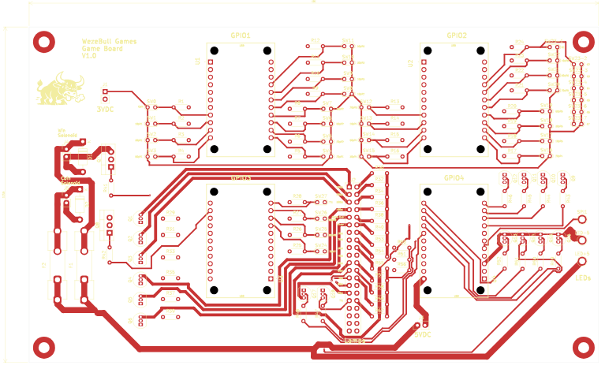
Game board (top copper) - FT232H sockets U1-U4 labeled with their serials.
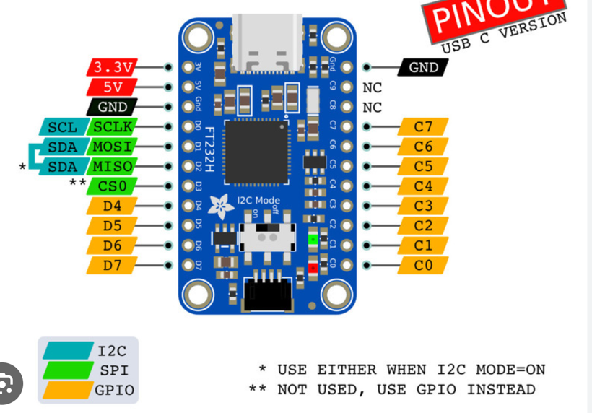
Adafruit FT232H pinout. D4-D7 / C0-C7 are the GPIO used; D0-D3 are SPI/MPSSE (only D1/MOSI).

12. Playing the game
- Insert a nickel - Coin Up (S0) arms the game at level 1.
- Flip the levers to send the nickel up the playfield.
- Land a hole in the current row - points added, score lamps count up to the new total, level advances.
- Reach a Row-8 (80-pt) hole - Winner lamp + win-lock solenoid.
- A gobble hole (S23) or Tilt (S27) ends the game.
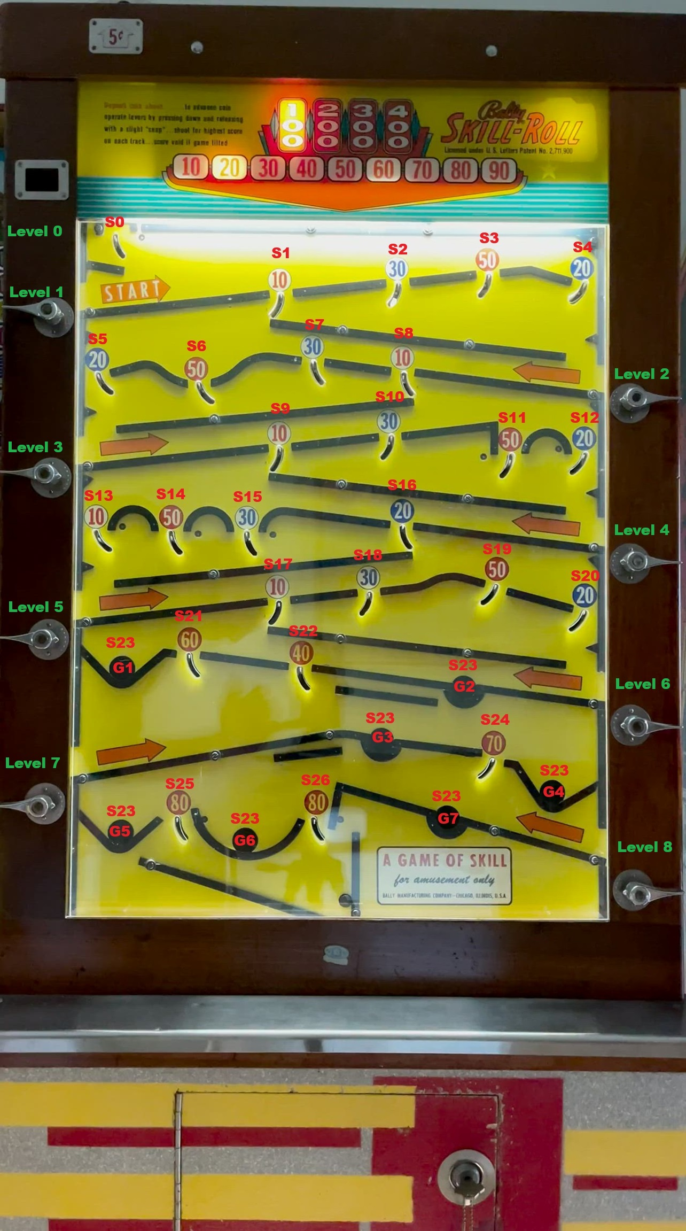
Playfield with switch (S0-S27) and gobble-hole (G1-G7) locations.

13. Troubleshooting
Symptom | Likely cause | Fix
'Hardware Not Ready' at startup | Not all 4 boards enumerated / serial not set | Confirm all 4 FT232H enumerate; program serials; check hub/cables (log has details). The form still opens and every tab is viewable - the game/lamp/LED functions just no-op, and Diagnostics shows 'POST: NO HARDWARE' - so you can work the diagnostics/audits screens with the boards unplugged.
A whole board's switches/lamps dead | Module in the wrong socket / serial mismatch | Put module GPIOn in socket Un (silk label).
No sound | Missing sound files / wrong path | Populate C:\SkillGame\Sounds\ subfolders.
A single lamp never lights | Driver / harness / wrong pin | Toggle it on the Diagnostics tab; check its PN2222A and the J2 harness.
Solenoid won't fire | Supply, TIP120, missing flyback, or blown fuse | Fire it on the Diagnostics tab; check supply & fuse; confirm TIP120 + 1N4004.
NeoPixel strip dark | 5 V supply or data pin | Power from 5 V (not USB); data on GPIO4 D1; check DIN direction.
Form looks huge/overlapping in the VS designer | 200% display + WinForms designer | Cosmetic only - it renders correctly at runtime; use 100% scaling or DPI-unaware designer mode.

14. Bill of materials
On-board electronics (from the KiCad schematic):
Qty | Part | Ref / value | Purpose
4 | Adafruit FT232H breakout (USB-C) | U1-U4 | USB -> GPIO / SPI
34 | SPST switch | SW0-SW27 (S23 = 7 gobble) | playfield hole switches
16 | NPN transistor | PN2222A | lamp drivers
2 | Darlington transistor | TIP120 (Q7, Q8) | solenoid drivers
2 | Diode | 1N4004 (D1, D2) | solenoid flyback
2 | Fuse | F1, F2 | solenoid protection
28 | Resistor | 10 kOhm | switch-input pull-downs
16 | Resistor | 1.0 kOhm | PN2222A base
2 | Resistor | 2.2 kOhm | TIP120 base
16 | Resistor | 220 Ohm | lamp current limit
2+ | Header | J1, J3 (power in) | 3.3 V / 5 V power
1 | 40-pin header | J2 | lamp harness
1 | LED-strip connector | SPI1 | WS2812b data + 5 V
4 | Mounting hole | H1-H4 | board mounting
External / system parts (not on the PCB):
Qty | Part | Purpose
1 | Windows mini-PC (16 GB, SSD) | game controller
1 | Powered USB hub | connects the 4 FT232H boards
1 | 10" capacitive touch monitor | diagnostics / audits display
1 | 3.3 V power supply | switch inputs
1 | 5 V power supply | WS2812b strip
1 | Lamp power supply | score / indicator lamps
1 | Solenoid power supply | coin-lock & win-lock coils
1 | WS2812b LED strip, 150 px | show lighting
2 | Solenoid | coin lock, win lock
16 | Lamps / bulbs | 10-90, 100-400, Game Over, Winner, Tilt
- | Wire, crimps, standoffs | assembly

15. Pin map reference
Logical pin numbers in code: D0-D7 = 0-7, C0-C7 = 8-15.
Board | Pad | # | Sw | Function | Row
GPIO1 | D4 | 4 | S0 | Coin Up
GPIO1 | D5 | 5 | S1 | 10 pts | R1
GPIO1 | D6 | 6 | S2 | 30 pts | R1
GPIO1 | D7 | 7 | S3 | 50 pts | R1
GPIO1 | C0 | 8 | S4 | 20 pts | R1
GPIO1 | C1 | 9 | S5 | 20 pts | R2
GPIO1 | C2 | 10 | S6 | 50 pts | R2
GPIO1 | C3 | 11 | S7 | 30 pts | R2
GPIO1 | C4 | 12 | S8 | 10 pts | R2
GPIO1 | C5 | 13 | S9 | 10 pts | R3
GPIO1 | C6 | 14 | S10 | 30 pts | R3
GPIO1 | C7 | 15 | S11 | 50 pts | R3
GPIO2 | D4 | 4 | S12 | 20 pts | R3
GPIO2 | D5 | 5 | S13 | 10 pts | R4
GPIO2 | D6 | 6 | S14 | 50 pts | R4
GPIO2 | D7 | 7 | S15 | 30 pts | R4
GPIO2 | C0 | 8 | S16 | 20 pts | R4
GPIO2 | C1 | 9 | S17 | 10 pts | R5
GPIO2 | C2 | 10 | S18 | 30 pts | R5
GPIO2 | C3 | 11 | S19 | 50 pts | R5
GPIO2 | C4 | 12 | S20 | 20 pts | R5
GPIO2 | C5 | 13 | S21 | 60 pts | R6
GPIO2 | C6 | 14 | S22 | 40 pts | R6
GPIO2 | C7 | 15 | S23 | Gobble G1-G7 | R6-8
GPIO3 | D4 | 4 | S24 | 70 pts | R7
GPIO3 | D5 | 5 | S25 | 80 pts | R8
GPIO3 | D6 | 6 | S26 | 80 pts | R8
GPIO3 | D7 | 7 | S27 | Tilt
GPIO3 | C0 | 8 | - | Coin Lock solenoid
GPIO3 | C1 | 9 | - | Win Lock solenoid
GPIO3 | C2 | 10 | - | 100 pt lamp
GPIO3 | C3 | 11 | - | 200 pt lamp
GPIO3 | C4 | 12 | - | 300 pt lamp
GPIO3 | C5 | 13 | - | 400 pt lamp
GPIO3 | C6 | 14 | - | Game Over lamp
GPIO3 | C7 | 15 | - | Winner lamp
GPIO4 | D1 | 1 | - | WS2812b data (SPI)
GPIO4 | D4 | 4 | - | 10 pt lamp
GPIO4 | D5 | 5 | - | 20 pt lamp
GPIO4 | D6 | 6 | - | 30 pt lamp
GPIO4 | D7 | 7 | - | 40 pt lamp
GPIO4 | C0 | 8 | - | 50 pt lamp
GPIO4 | C1 | 9 | - | 60 pt lamp
GPIO4 | C2 | 10 | - | 70 pt lamp
GPIO4 | C3 | 11 | - | 80 pt lamp
GPIO4 | C4 | 12 | - | 90 pt lamp
GPIO4 | C5 | 13 | - | Tilt lamp

16. Schematic & PCB notes
Both are electrically complete and correct - the software, spec, playfield and netlist all agree, and the board passes DRC with 0 violations and 0 unconnected nets. Two 'nicer for v2' notes (neither is required):
- Schematic: it is one flat B-size (11x17) sheet with ~140 parts. That is fine, but it is busy - the long wires carrying the GPIO3/GPIO4 outputs across to the J2 harness and the 220-Ohm bank are the clutter. Easiest cleanup: replace those long runs with net labels (stays one page). For a textbook-clean set, go hierarchical - one sheet per FT232H board. Also fill in the empty title block (Title / Rev / Date).
- PCB: correct and manufacturable but hand-routed and loose. The full step-by-step tidy-up plan is in SkillGame_PCB_v2_Layout_Plan.md (placement first, then route, ground stitching, net classes, rebalance).

17. Service & show features

Added in this build
- Service tools (Diagnostics tab): a guided WIRING TEST that walks each switch and confirms it's on the right pin; a power-on self test (POST) that checks the boards + flashes the lamps/strip at startup and shows PASS/FAIL; an on-screen LOG VIEWER (tail of skillgame.log); and a live I/O MAP (floating window) that lights the actual FT232H pin - green for inputs, amber for outputs - as you trip a switch or push a button. Plus the BULB TEST (walks every lamp) and the Hardware Status board readout. All tests/diagnostics live on this tab.
- Operator Setup (Settings tab): tune and SAVE the score count-up speed, tilt on/off, and overnight quiet-hours cap (start/end/volume) to operator_settings.json - values that used to be hardcoded.
- Game Status: a DEMO GAME button that plays a full self-test game - score climbs, levels advance, lamps and sounds fire - with no coin or playfield, paced like a real game (about 12 seconds between scores so the sounds and light shows play out). Click it again (STOP DEMO) to cancel and reset the game to idle.
- Audits: a high-score table, per-switch health coloring (dim = not exercised this power-cycle), and RESET (with confirmation) + EXPORT-to-CSV. The Audits tab holds only the books; hardware tests moved to Diagnostics.
- Interface polish: the whole form uses rounded, glass-look buttons; the Game Status screen is now a proper scoreboard with a large SCORE readout as the hero element; and every control still scales to fill any screen resolution.
- Show lighting: reactive strip effects - coin ripple, points-keyed score flash, winner fireworks, tilt strobe - plus new selectable patterns Fireworks / Starfield / Aurora / VU Meter (audio-reactive).
- Deployment: a kiosk watchdog (SkillGame_Kiosk_Watchdog.ps1) that relaunches the game if it exits, with logon-registration instructions inside it.
- Optional quiet hours: caps the master volume overnight - off by default; enable it in QuietHours.cs (Enabled / StartHour / EndHour / QuietPercent).

Status
Nothing major is outstanding - the earlier wish-list (extra diagnostics, audits + high scores, reactive show lighting, new patterns, VU meter, the persistent level meter, and the kiosk watchdog) is all implemented. 'Free-play vs coin' modes don't apply to this machine: the physical nickel is the gameplay (you flip the real coin up the playfield), so there is nothing to gate with credits.

18. Notes & to-do
Add your own build notes, changes, and open items here.
- (your notes...)

